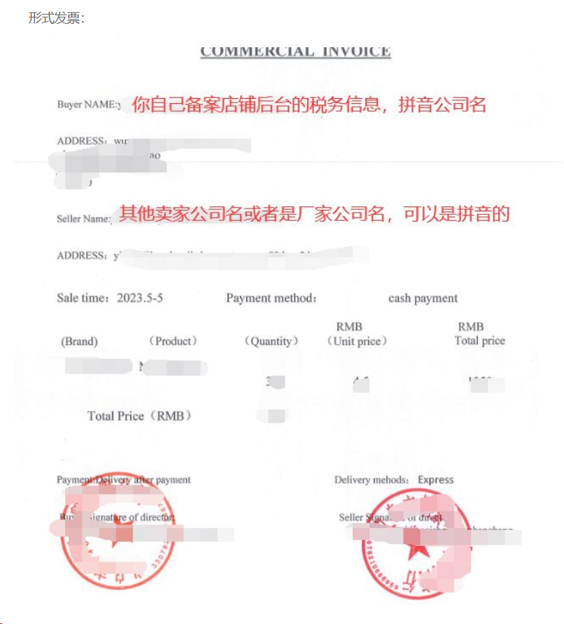

COMMERCIAL INVOICE
Buyer Name
Address
Seller Name
Address
Sale Time |  | Payment Method | Cash Payment

Brand | Catalog | Product Name | Quality | Unit Price(￥) | Total Price(￥)
 |  |  |  | TOTAL(￥)

Payment: Delivery after payment Delivery Methods: Express

Signature of Seller: Signature of Buyer:

